REPORT file
VITYARTHI PROJECT


TOPIC: MICRO MARKETPLACE

BY:
MAHI
(25BACE11317)


VIT Bhopal University
Kotrikalan – 466114
Madhya Pradesh INDIA
December 2025

Project overview

- Introduction:
. This project focuses on developing a Python-based utility program designed to diagnose and fix common browser search engine redirection issues. Many users experience situations where their browser searches unexpectedly open in Yahoo or another unwanted search engine instead of Google. This usually happens due to browser setting misconfigurations, extensions, or hidden redirects.
The Python program provides a lightweight, backend-only solution that helps users scan basic settings, detect anomalies, and display simple diagnostic results.

- Problem Statement:
Users often face the issue where their browser searches open in Yahoo instead of Google, even though Google Chrome is installed. This change typically occurs because:

A browser extension or add-on modifies default search settings.

The system installs a third-party browser or toolbar that resets the search engine.

Browser configuration files become corrupted.

A hidden redirect affects the URL being searched.

Most users are unaware of how to manually fix such settings. Therefore, a simple Python-based tool is required to:

Accept a website or search keyword from the user.
Simulate how the system would open it
Detect abnormal redirects.
Inform the user if their browser settings might be affected
- Functional Requirements:
- FR1: The system must accept user input (website URL or search term).
- FR2: The system must validate whether the input is a URL or search keyword.
- FR3: If the input is a URL:
- The system should generate a simulated “opening URL…” message.
- FR4: If the input is a search keyword
- The system should generate a simulated Google search link.
- FR5: The system must clearly show the final output to the user.
Non-Functional Requirements:
NFR1 – UsabiThe tool must be easily understandable for beginners.
NFR2 – Performance:The tool must run instantly with minimal resource usage.

NFR3 – Reliability The program should output consistent results for correct inputs.

NFR4 – Maintainability: The program must have simple logic that can be expanded later.

NFR5 – Portability: The tool should run on any system with Python installed.

- System Architecture:
The project follows a linear architecture:
User Input → Input Validator → Type Classifier (URL/Search)
↓ ↓
URL Handle Search Handler
↓ ↓
Output Generator → Display Result
Key components:
Input Layer – Collects user queries.
Processing Layer – Detects URL or keyword.
Logic Layer – Generates simulated results.
Output Layer – Shows the final result.

Design Diagrams:

  - Use Case Diagram:

+-------------+

| User |

+-------------+

|

v

+------------------+

| Enter Input |

+------------------+

|

+-------------+

| System |

+-------------+

/ \

URL Search

Handler Handler
B)Sequence Diagram:
User → Program : Enter input
Program → Validator : Check format
Validator → Program : Result (URL/Search)
Program → Handler : Process accordingly
Handler → Program : Message generated
Program → User : Display message

C)Class Component diagram:
+---------------------+
| Main Program |
+---------------------+
| - user_input |
| - result |
+---------------------+
| + classifyInput() |
| + generateOutput() |
+---------------------+

+---------------------+
| URL Handler |
+---------------------+
| + openURL() |
+---------------------+

+---------------------+
| Search Handler |
+---------------------+
| + createSearchLink()|
+---------------------+

- Design Decisions & Rationale:
Decision 1: Use basic string checks
Instead of importing heavy validation libraries, simple "." detection is used to classify URLs. This keeps the program lightweight.

Decision 2: Use console-based output
Skipping frontend and GUI ensures portability and simplicity.

Decision 3: Keep logic modular
Breaking logic into handlers makes future upgrades easier.

- Implementation Details

The program is implemented in Python using:
Input function for user interaction
Conditional statements for classification
String operations for generating results
Core logic flow:
1. Take input
2. Check if it looks like a URL
3. If URL → print “Opening URL…”
4. If keyword → print Google search simulation
Screenshots/Results:

- Code:

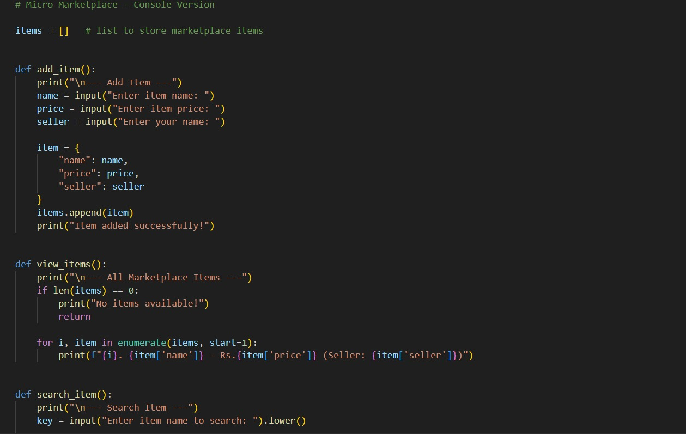

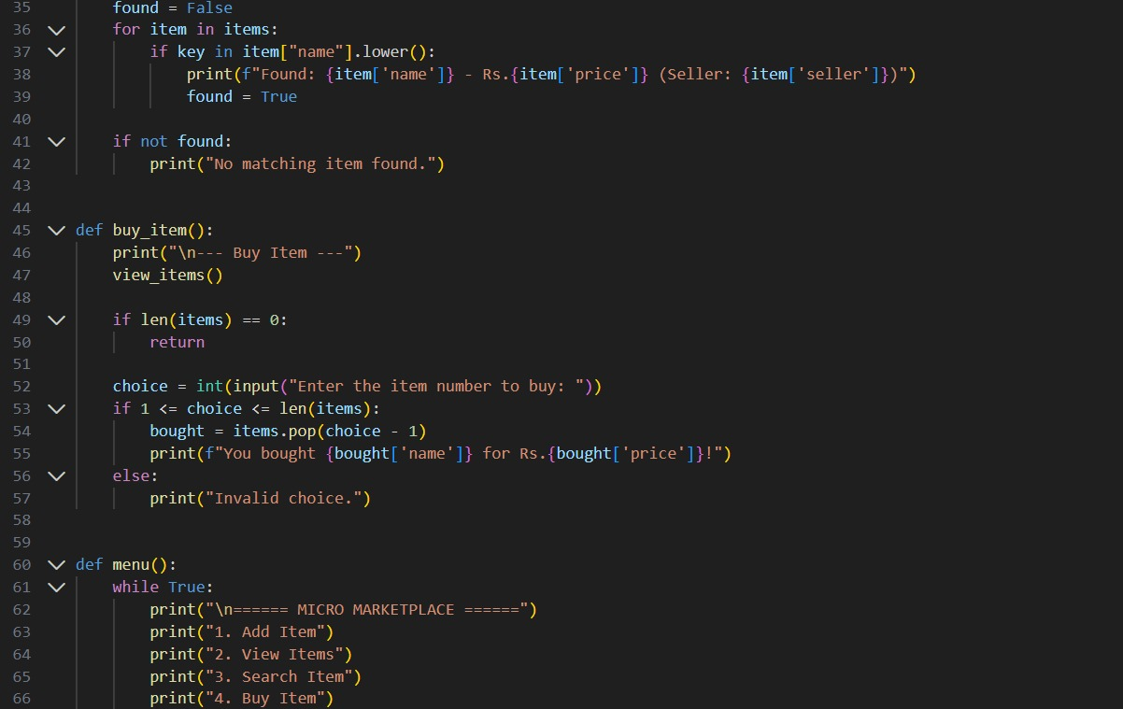

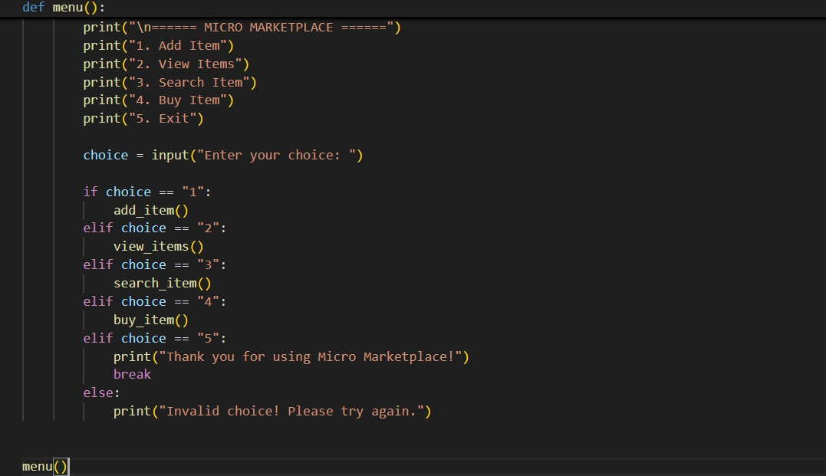
OUTPUT:

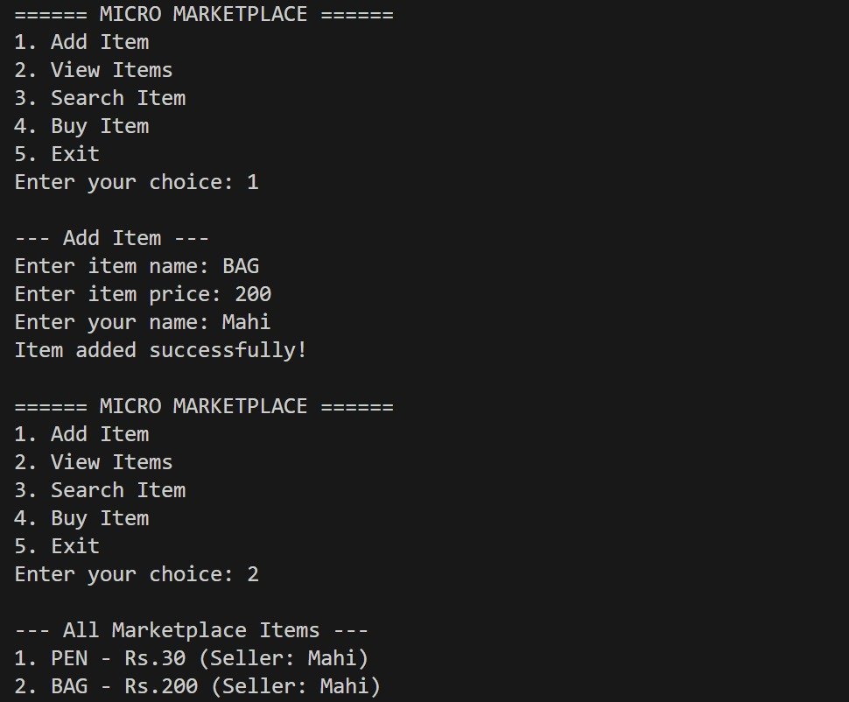

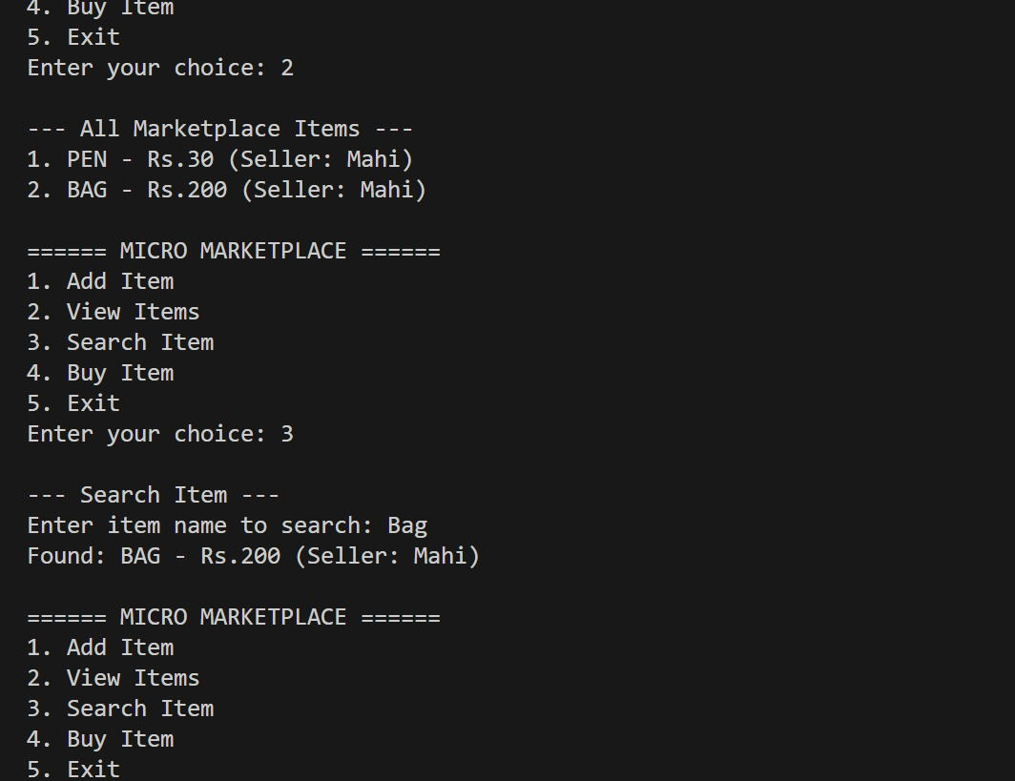

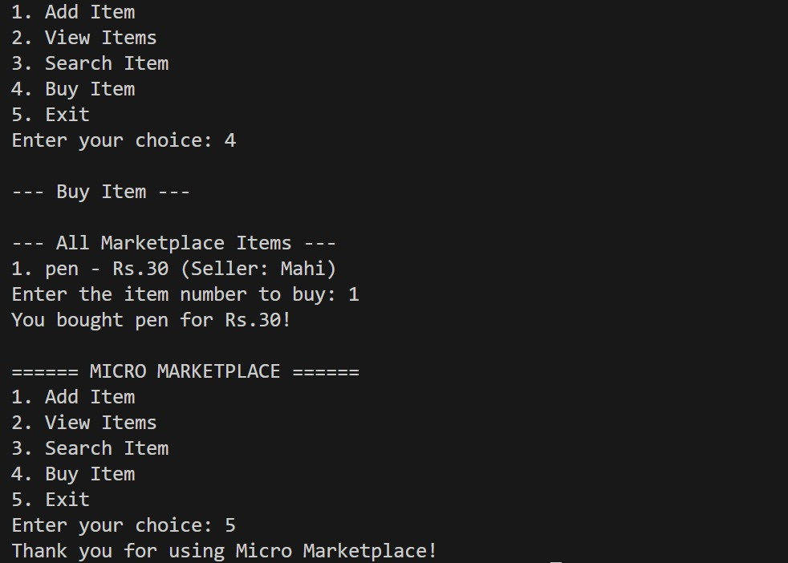

Testing Approach:
Test cases performed:
Test Input Expected Output Result

google.com Opening URL: google.com Pass
hello world Google search link generated Pass
youtube https://www.google.com/search?q=youtube Pass
http://example.com Opening URL Pass
Testing methods:
Manual testing for multiple keywords.
Boundary testing (empty input → handle gracefully).
Negative testing (random symbols).

Challenges Faced:
Differentiating URLs and keywords without overcomplicating logic.
Avoiding any frontend or browser-based automation.
Handling inputs that are partially URLs but not fully valid.
Making the output meaningful even with minimal backend logic.

Learnings & Key Takeaways
Learned how search redirection happens and how to simulate search behavior .Improved understanding of input-handling and Python string logic.
Gained experience in modeling diagrams and architecture without GUI.
Understood lightweight backend design principles.

- Future Enhancements
Learned how search redirection happens and how to simulate search behavior.

Improved understanding of input-handling and Python string logic.

Gained experience in modeling diagrams and architecture without GUI.

Understood lightweight backend design principles.

- References
Python official documentation
W3C URL structure guidelines
Browser search engine troubleshooting articles
Basic software engineering design principles

